Sky Surveys
Materials:
- This lab is 100% online.

Student Learning Objectives:
- Become acquainted with all-sky or large area astronomical surveys.
- Practice working with actual survey data.

Watch:
- SDSS releases largest 3D map of the universe ever created
- A Flight Through the Universe, by the Sloan Digital Sky Survey
Read:
The Sloan Digital Sky Survey has created the most detailed three-dimensional maps of the Universe ever made, with deep multi-color images of one third of the sky, and spectra for more than three million astronomical objects. Learn and explore all phases and surveys—past, present, and future—of the SDSS.
- Go to the following site: Sloan Digital Sky Survey (SDSS) to find the most recent news story.
- Insert a screenshot of the image, and describe the finding in a paragraph. This needs to be your own words, describing the image and significance of the finding. What new information does this reveal?
Procedure:
This lab uses the SkyServer website hosted by the Sloan Digital Sky Survey. The questions and exercises on the website are repeated here for you to answer. For this lab we will be working with the Sky Surveys exploration. Go through each of the pages, clicking NEXT to progress. Be sure to read the info on each page.
Part I: Comparing Two Surveys
Make sure you are following the link here Sky Surveys exploration for each step! There is critical information on each page, and if you are not following along you will likely NOT end up on the right server for each section.
You can access the POSS I survey (and what is complete of the POSS II) by clicking here. Launch the navigation tool for the SDSS by clicking here. Both interfaces will open in new windows.

Let’s look at the field containing PAL 3, a globular cluster discovered by POSS (also featured in SkyServer’s H-R diagram project).

- In the POSS interface, type PAL 3 in the field labeled “Object name” then click Get Coordinates. You will see the coordinate appear in the box below.
- Click no File Format, and change to a .gif. Unless you have a special viewer for .fits files and want to use that.
- Click retrieve image.
- Get the SDSS image. If you have not already, open the Navigation Tool.
When this opens, you should see an image like this:

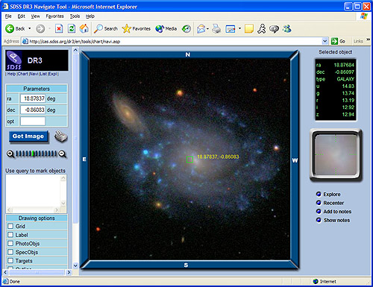

- In the "ra" and "dec" boxes, enter the coordinates for Pal 3: ra = 151.3801, dec = 0.072.
- Click Get Image. A picture of Pal 3 will come up in the main window.
- You should now have two images of Pal 3: one from POSS I and one from the SDSS.

Insert both images below:

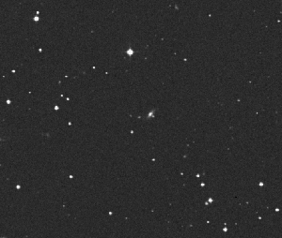
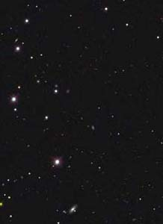
Question 1.
- What differences do you notice between the pictures?
One is darker than the other.
- Are the pictures oriented the same way, or are they rotated and/or flipped?
They are not oriented in the same way,one is in potrait orientation.
- Does one picture show fainter stars than the other?
Yes
- Describe how the stars appear in each.
In the SDSS,the dtars appear to be fainted compared to those in POSS.
- Does one show more detail?
Yes
- Does one show better color?
Yes

Question 2.
- Compare the new images you obtained from the SDSS and the POSS I.
- What do you think are the most important differences between the images? (describe in a few sentences).
The most important differences is that the two images appear to be in different orientation.The SDSS is in potrait. The two are also different in how the stars appers,in POSS the stars there are brighter and clear .

Read the following information on PAL 3.
Globular cluster Palomar 3 probed by Russian astronomers Aug 10, 2020
Which image appears to be better to study the properties of this object? Why?
Click NEXT.
The one in POSS because it is more clear and can be zoomed more. By conducting deep photometric and medium-resolution spectroscopic observations, Russian astronomers have investigated Palomar 3, a distant galactic globular cluster. Results of this observational campaign provide more insights into the properties of this cluster, which could be essential in improving our understanding of its origin.
Part II: Finding Supernovae
Make sure-again-you are following along on the webpage!
Read information on the site page (Skyserver, from the beginning)
Summarize what supernova are and the role of sky surveys in three bullet points:

Compare the images closely. A supernova is visible in the SDSS image. Can you find it? Be careful that you are not just picking out a very faint object that was not visible in the POSS image!
Exercise 1.
- Now, find the other two supernovae in the SDSS's Early Data Release. If you are reading this, put your initials in red at the bottom of this section, in 20 pt font.
- The table has links to images of the SDSS fields that contain the supernovae.
- Click the "small" link for a small image, and the large link for a large (2048 x 1489) image. Both types of image will open in the same new window.
- After getting the SDSS image, use the given RA and Dec in the POSS Image Retrieval tool to find POSS images of the same field.
- Compare the fields to find the supernovae. (Note: the images are not oriented the same direction!) The second supernova is rather hard to find.
  - This is tricky! It may help to put the screenshot here on your page, side by side, and change the orientations to match.
  - Use the examples on the webpage to compare, so you know what to look for. Remember you are comparing each of your images, and finding something in one that is not in the other….Hints on the skyserver site!
Coordinates
- Supernova #1: RA = 353.18, Dec = -0.98
- Supernova #2: RA = 18.12, Dec = 0.13

Please include a screenshot of your page at this point with the supernovae circled in RED or with a RED Arrow.
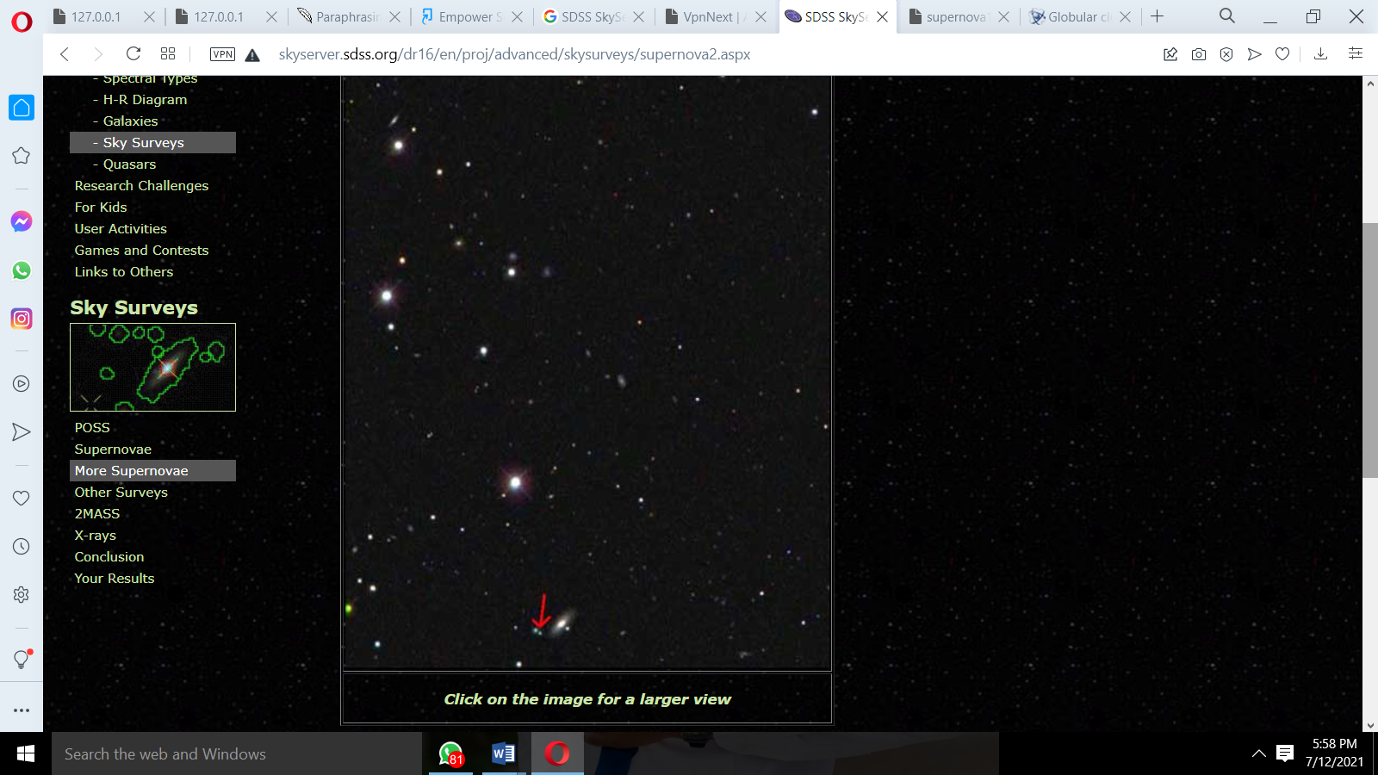

Part III: SDSS and 2MASS Images
Read: Other parts of the EM Spectrum
Summarize the role of sky surveys in multi spectral imaging in 3 bullet points:
- to map in a systematic way the universe and its constituents
- discover new types of objects or phenomena.
- wide-field imaging

Click NEXT
- Go to SkyServer's Famous Places.
- Click on Galaxies, and find NGC 4753. Look at its image.
- Then click the link to the 2MASS Data.
- Type NGC 4753 for the object name and click Submit. Scroll down until you see an image of the galaxy.
- You should now have two images of NGC 4753, in two separate windows.
- Screenshot and insert both below
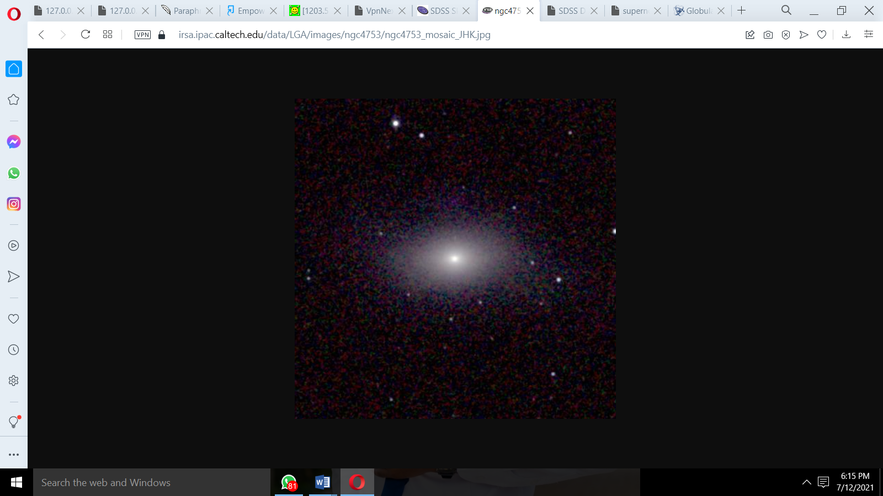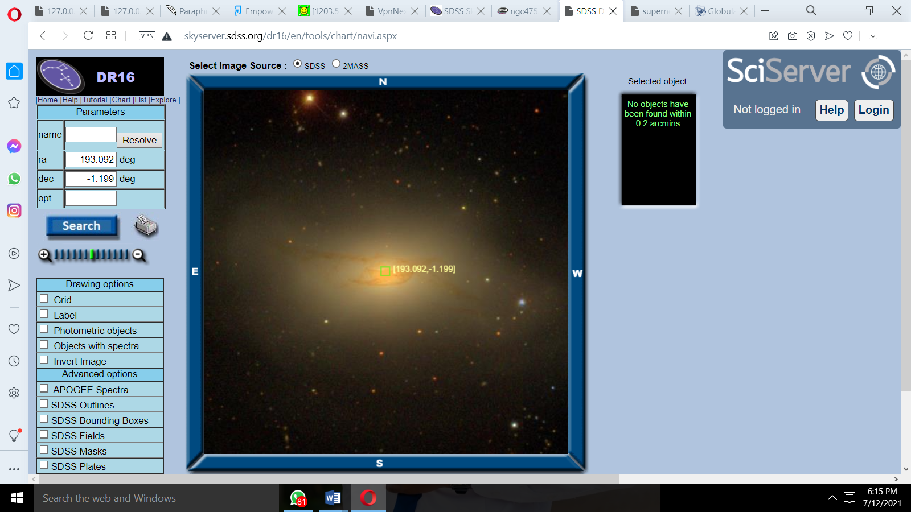
Question 4.
- How do the two images appear different?
One is more clear and detailed than the other.
- What do they have in common?
Both are images focusing on a bright object in the sky.
Question 5.
- Based on these two images, what do you think are the advantages of looking at an object in the infrared instead of the visible spectrum? This should be a couple complete and descriptive sentences.
One of the advantages of observing in the infrared is that dust is transparent to it. This is why a visible spectrum would be unable to see a star enshrouded in dust, whereas one working in the near-infrared would be able to detect its emission. As one proceeds further into the far-infrared the emission from the dust itself becomes observable.
Exercise 2.
- All the objects below are in the SkyServer's Famous Places.
- Browse through the six categories of Famous Places and find their images.
- Look up their images in the 2MASS data.
- Insert all images below.
- Compare and contrast the images for three or four of the objects, and insert below the images (you will have to right click and add a line below those cells). Identify features which are similar and different.
Name | SDSS Image | 2MASS Image
NGC 4437 | 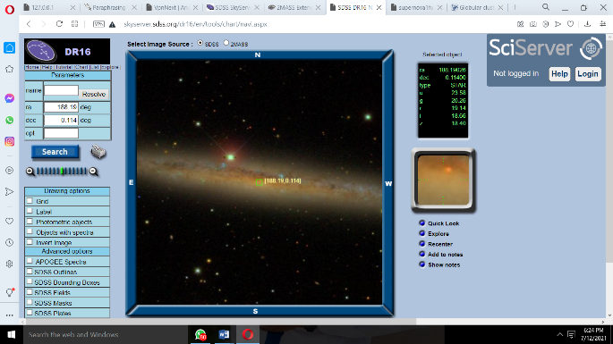 | 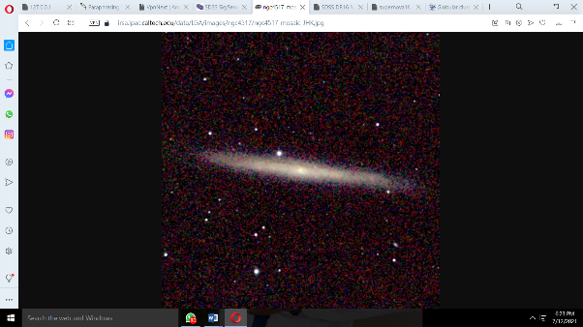
NGC 936 | 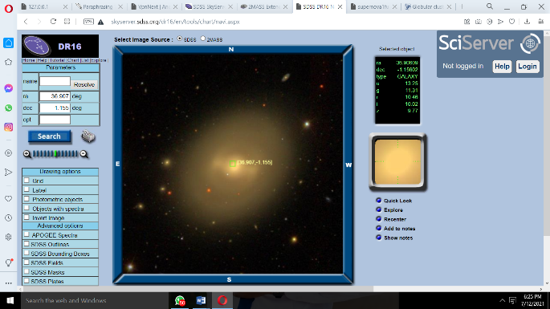 | 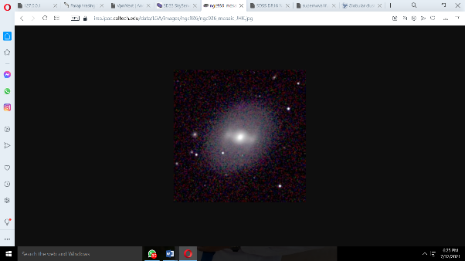
NGC 3521 | 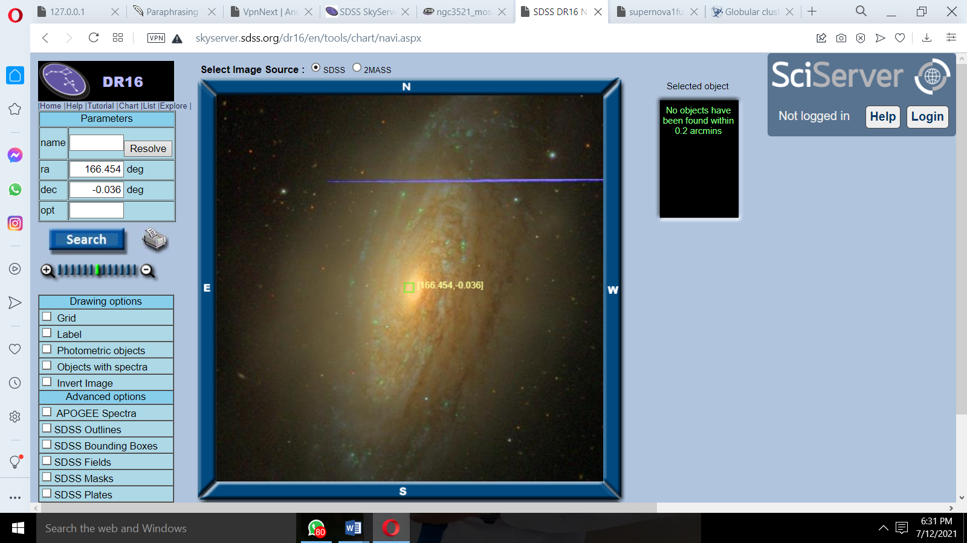 | 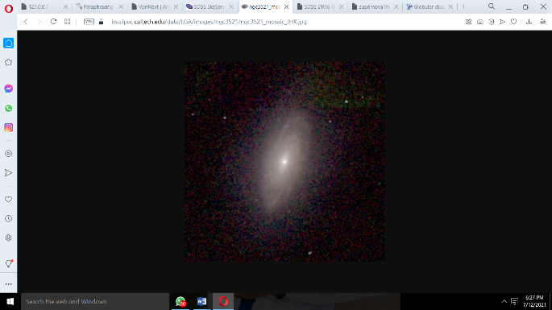
NGC 1087 | 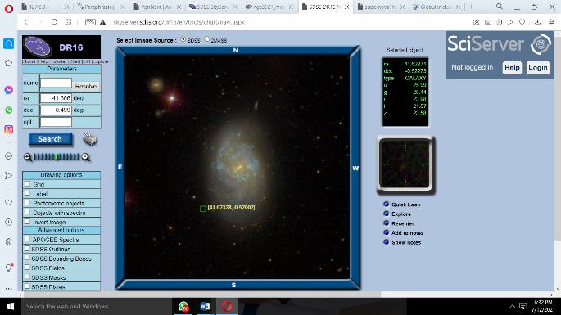 | 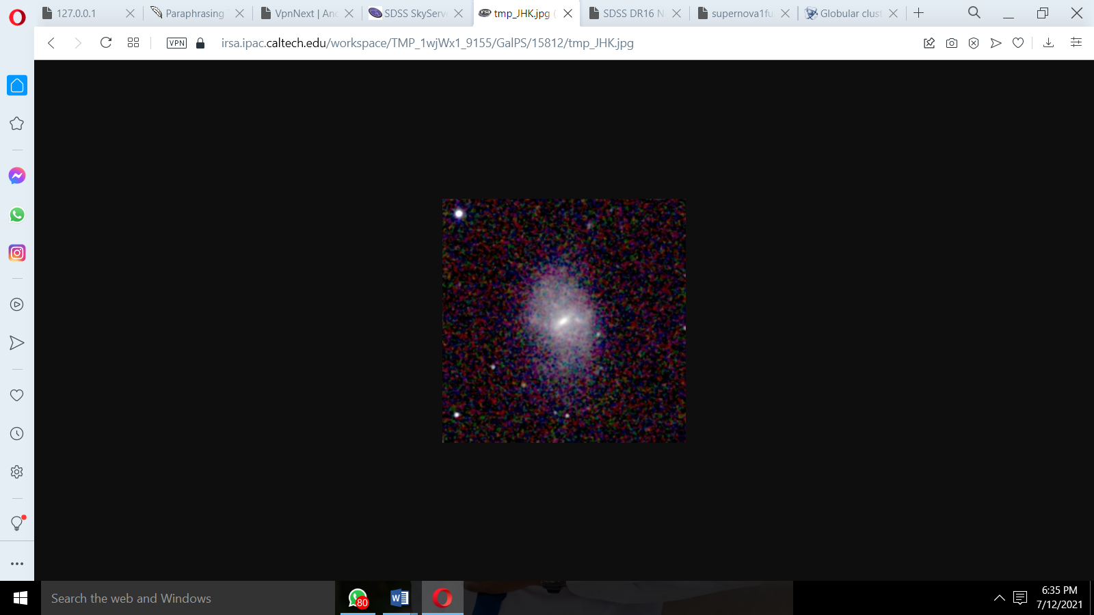
NGC 5334 | 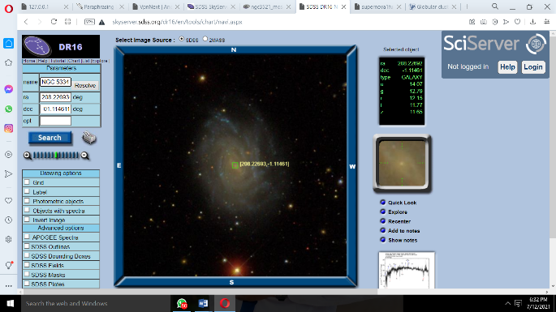 | 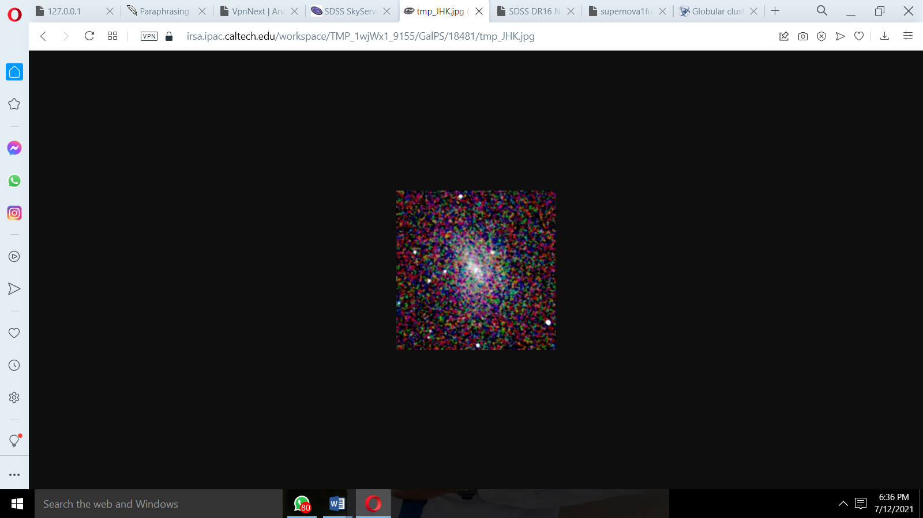
NGC 5750 | 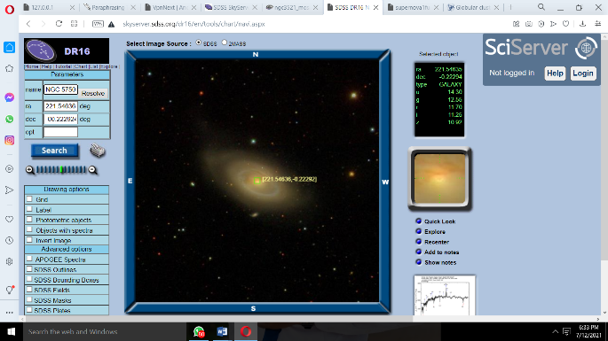 | 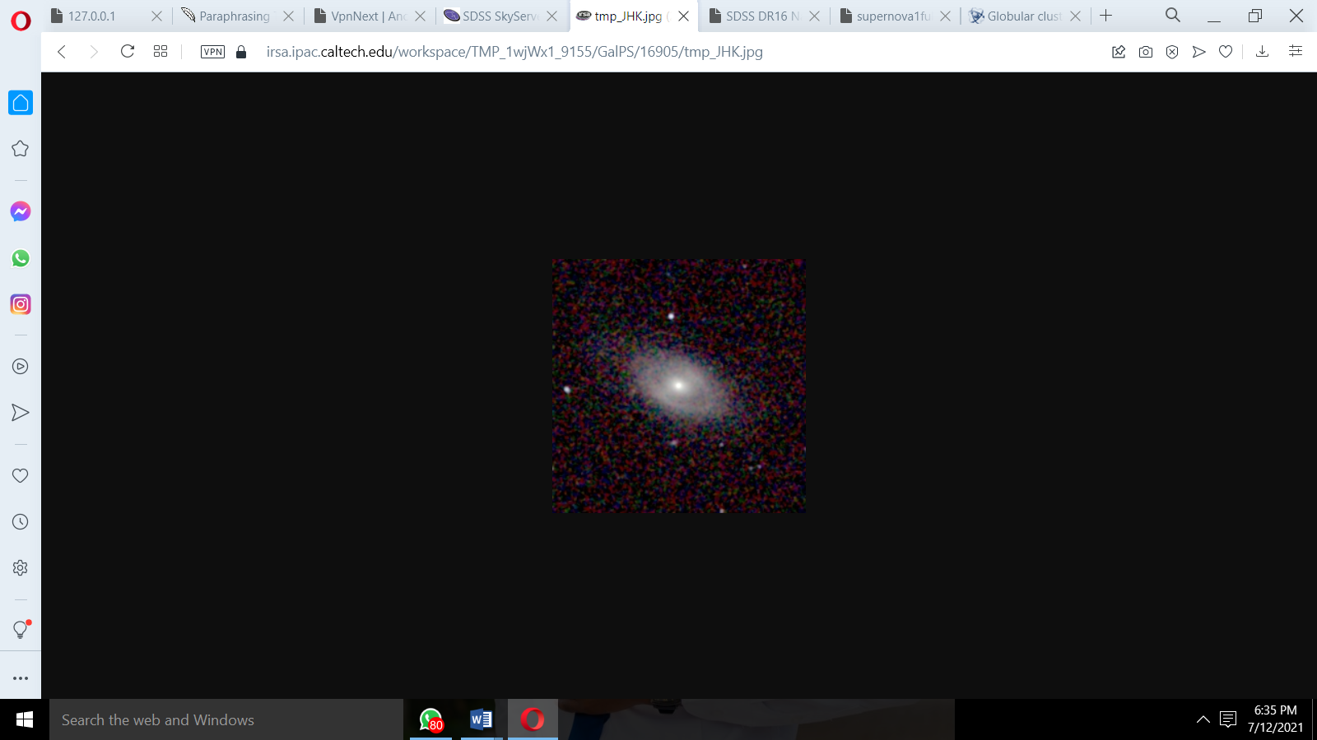
NGC 799 & NGC 800 (same frame in SDSS) | 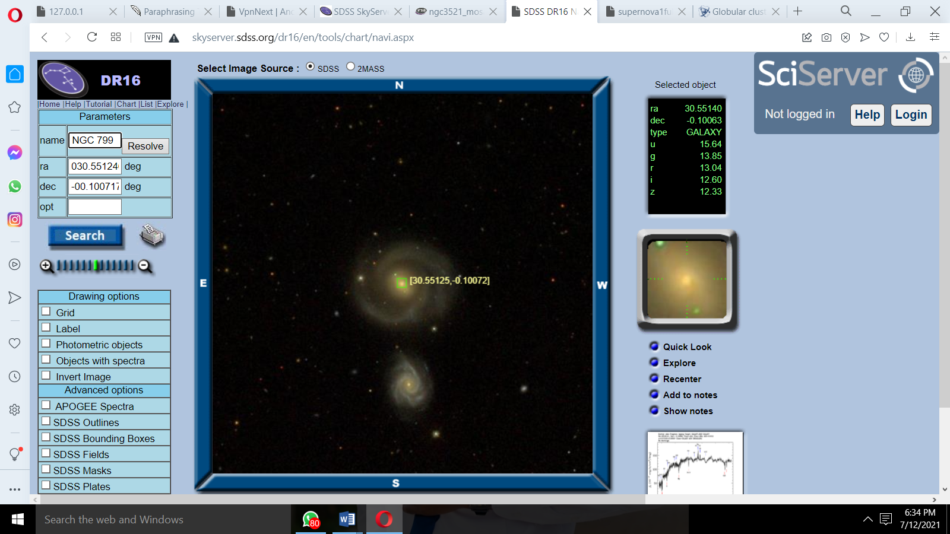 | 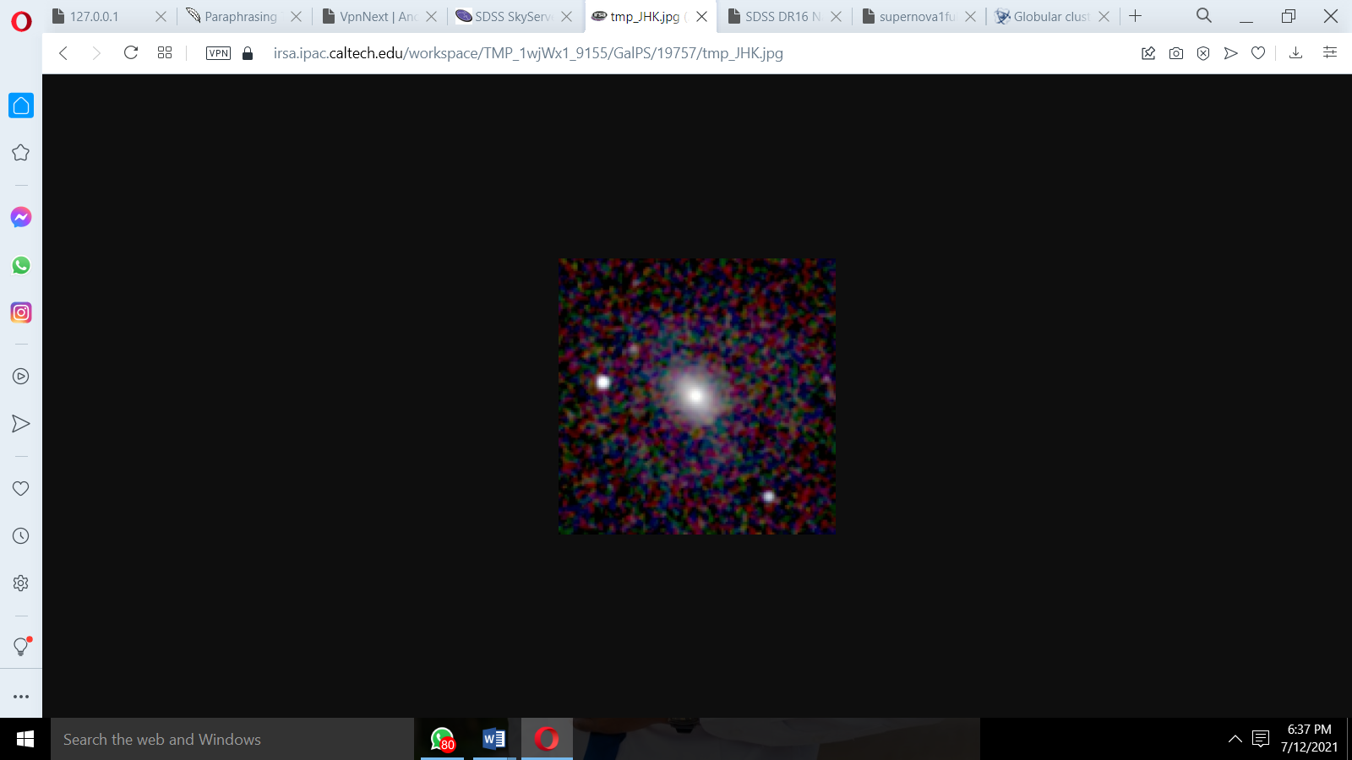

Part IV: The X-Ray Sky
Read: The X-Ray Sky
Summarize the role of sky surveys in X-Ray Astronomy in 3 bullet points:
- discovering the unexpected as they scan the entire sky over a large range in energy.
- discovery and study of hot gas within clusters of galaxies
- X-ray observations also revealed the dynamic nature of clusters, including shocks and bubbles of gas

Exercise 3.
- Open the ROSAT Search Page.NOTE-as of 5/13 am this site was down. If it is still down, do not worry about this component and go to the next step.
  - In the lat and lon boxes, enter the coordinates 150 and 0 (these are the RA and Dec coordinates).
  - Click "Coordinates." A new window will open with an image of part of the sky as seen in x-rays. Click on any of the numbered objects that lie between Dec = -1.2 and Dec = 1.2 (this is the area covered by SDSS). Another window will open telling you the RA and Dec of the object.
- Now, open the Navigation Tool. You should see a screen like this:
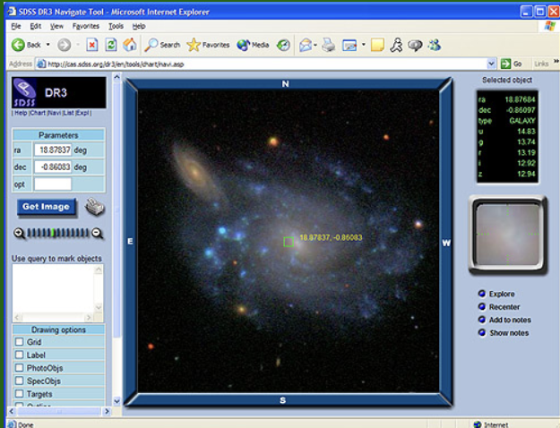

- Click anywhere on the screen to select an object.
- In the boxes marked "ra" and "dec," enter the RA and Dec of the object you selected, then click "Get Image."
- A new image will come up in the main window, centered on the object you selected. The object's data will appear in the right-hand frame.
  - Under this, select Quick Look and Explore.
- Please include a screenshot of your image AND your Navigation Page (like above)
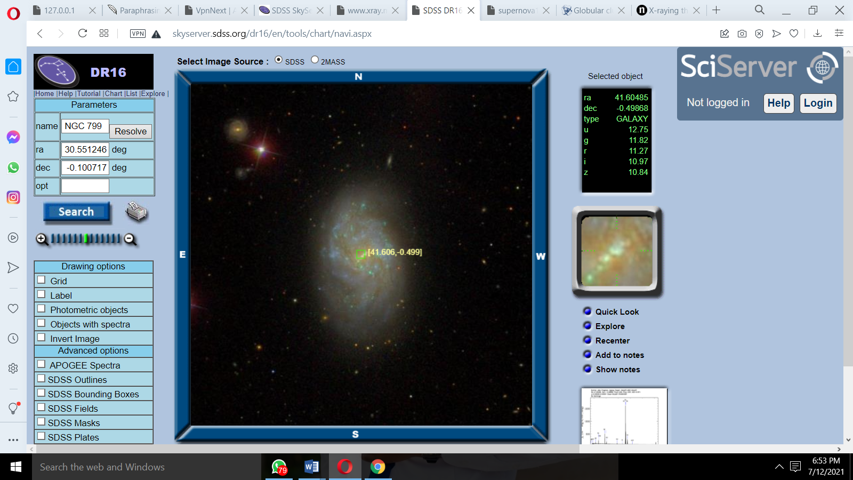
- Include a screenshot of the SPECTRA and circle the ELEMENTS AT THE DIPS (these indicate the elements which are being absorbed by the object)
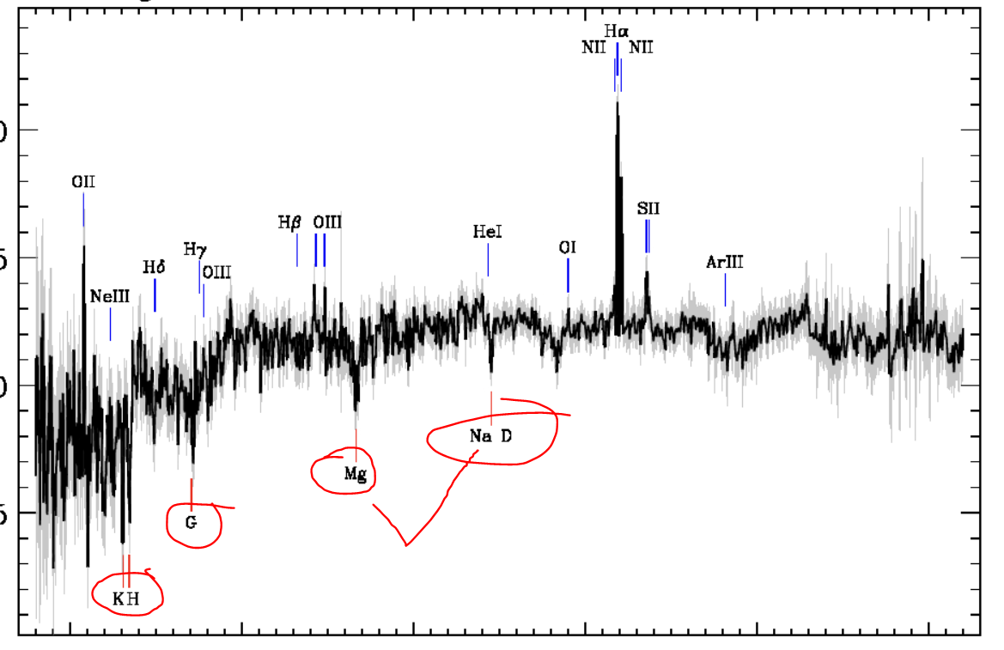
Here you can see I circled Magnesium and Sodium-which means this star was absorbing those elements.
Question 6. NOTE-this may not be possible with the ROSAT link down.
- What type of object is the optical counterpart to the x-ray source you chose?
The star
- Does it stand out when you look at it in the visible wavelengths, or does it look like a lot of the other objects?
It stands out.

Question 7.
- What do you think are the advantages of looking at objects in the x-ray region of the spectrum? (you can use the following sites) This should be either bullet points or a paragraph of your own words.
- X-ray Astronomy
- More about Chandra
- The provide more clear images.
- They provide more detailed images

Exercise 4. Go to this site, and select a video or podcast.
- Describe the object from the video or podcast in a few sentences or bullets.
An object explotion in the galaxy.

- What information is revealed by X-rays from this object?
A nebula is an enormous cloud of dust and gas occupying the space between stars and acting as a nursery for new stars. The roots of the word come from the Latin nebula , which means a “mist, vapor, fog, smoke, exhalation.” Nebulae are made up of dust, basic elements such as hydrogen and other ionized gases
- What type(s) of objects tend to give off x-rays?
X-rays have very short wavelengths and high energies compared to visible light. If an astronomical object gives off x-rays, it must be a hot, bright object that gives off a great deal of energy.
Bonus Research Challenge.
Select an object that interests you from the SDSS database. It could be an object from the Famous Places list, or an object you find with the Navigation Tool. Look up data on the object in POSS, 2MASS and any other sky survey databases you can find.
- What is the object?
A star
- What does it look like in different surveys?
It is clear in the SDSS and not clear in the POSS.
- Why do you think it looks the way it does?
This is because the infrared used in the SDSS makes it to appear more clear in the photo.
- What other data (spectra, for example), can you find for the object?
The object has dust around it.

Zooniverse Galaxy Zoo: Citizen Science Project

Introduction
Engineers take scientific knowledge, usually from multiple scientific disciplines, and apply it to create useful technology. On the Zooniverse website and in the questions below, you will learn more about how multiple scientific and engineering disciplines are applied to create innovative technology that employs citizen science to achieve its goals.

Instructions:

How to register an account at Zooniverse at https://www.zooniverse.org:

Click on the Register link in the upper right corner.  You will use the Sign-In link after account creation. | 
Fill in your information.  Username: shorty87  Password: losangeles87 | 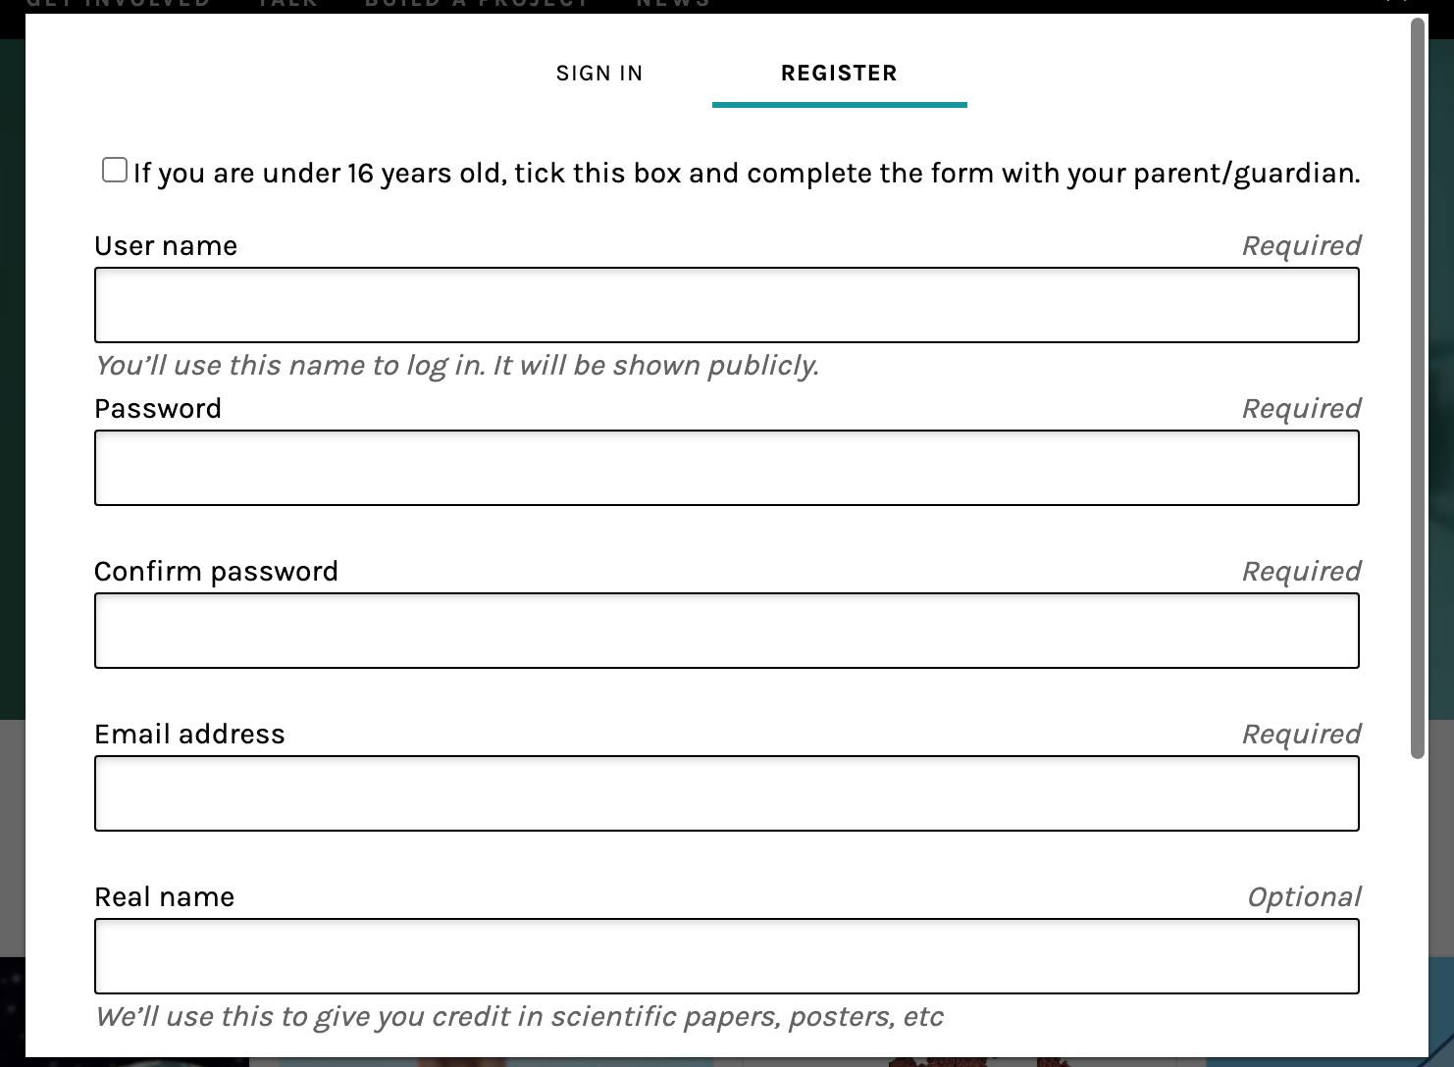

Finding Galaxy Zoo on Zooniverse:

Under the Projects link, scroll down to find the list of project types.  Use the right arrow to bring the Space category into view. | 
You will find Galaxy Zoo (and many other fascinating projects) on the Space page. | 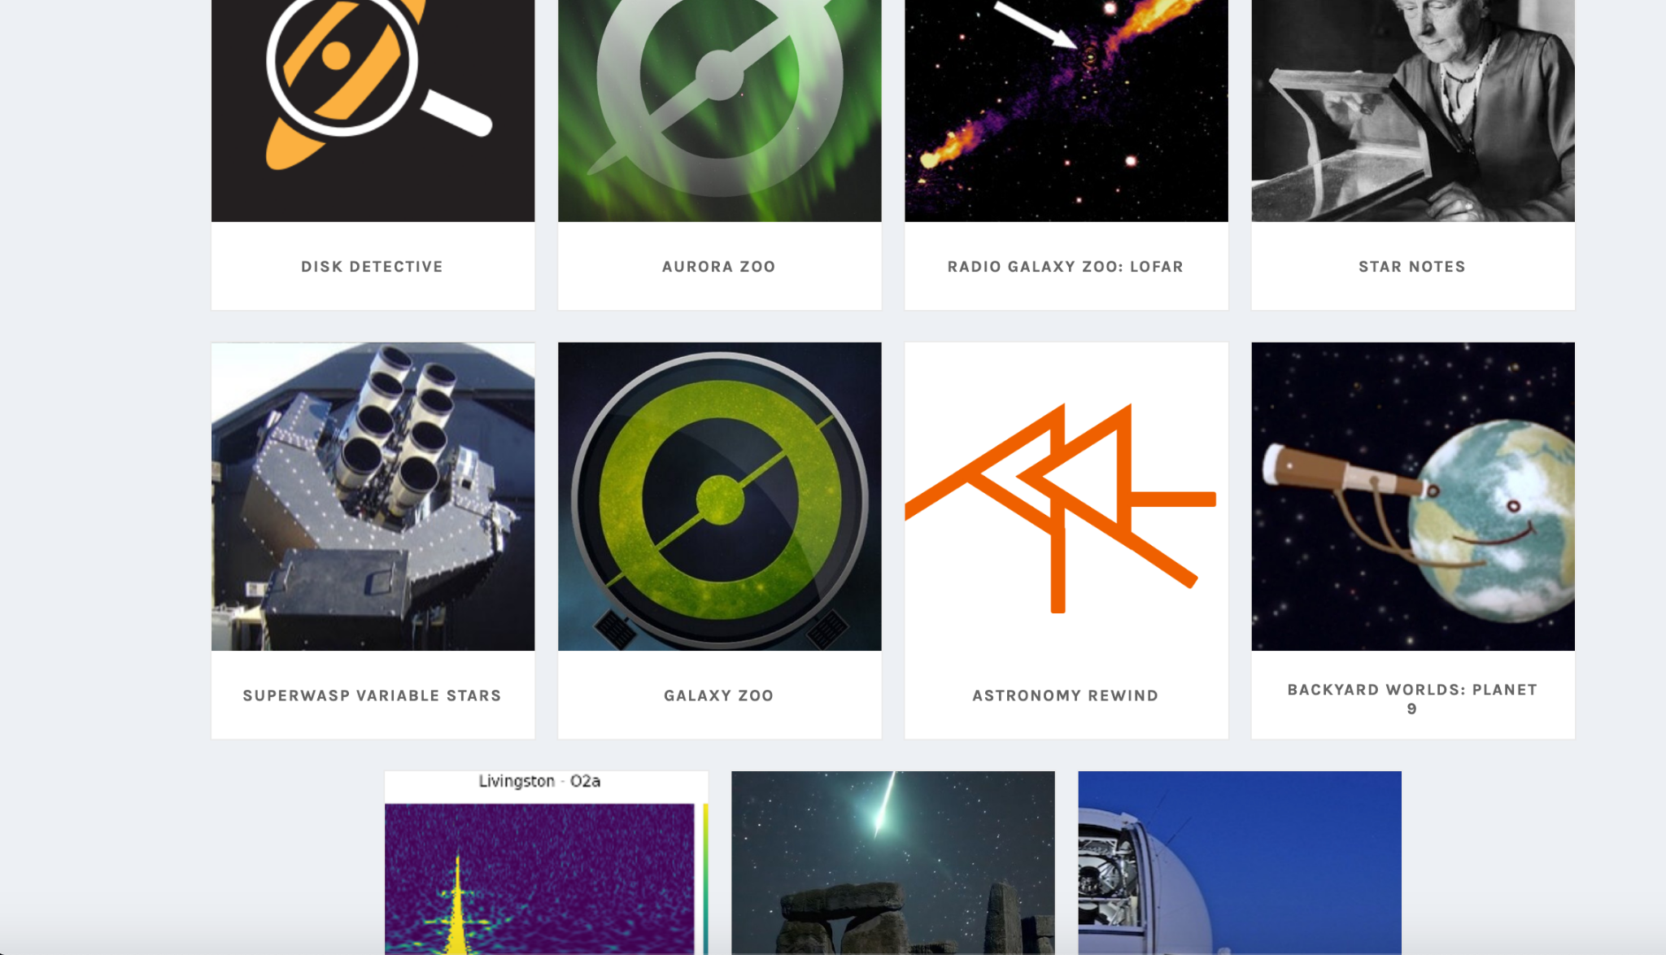
Here’s the opening page for Galaxy Zoo. | 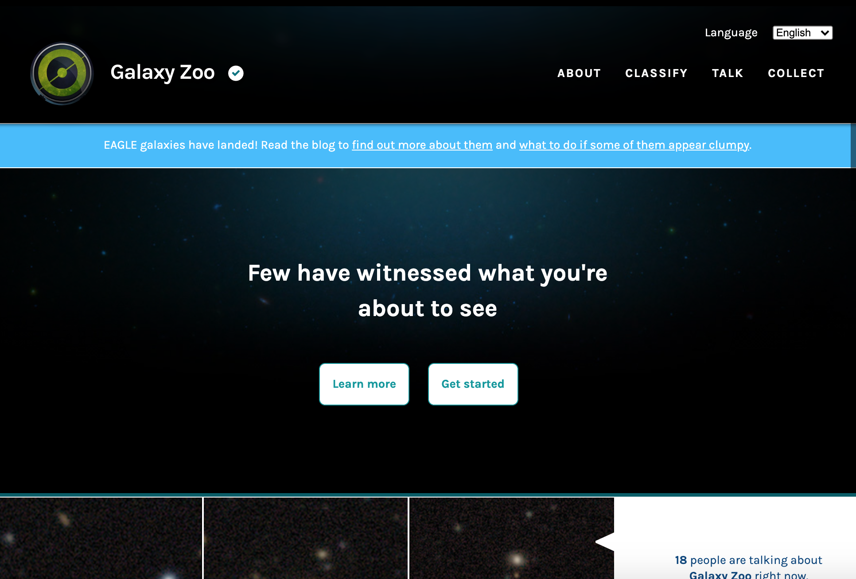
You can also use the direct link. | https://www.zooniverse.org/projects/zookeeper/galaxy-zoo/

Questions

- What does this project monitor and how?
This project helps classify a million galaxies by using people and science to classify them.
- What are some significant features of the Galaxy Zoo project?
The use of a “clustering algorithm”. Clustering algorithms are a very broad class of techniques used to identify clusters of points in space, and most of them are very simple to implement and run
Hint: look for the “About” section, science section, blog section and/or similar pages of the project website to provide more detail on this. (2-3 sentences)

- What is the role of the non-scientists/citizens in this project?
Those involved are directly contributing to scientific research, while getting an opportunity to view the beautiful and varied galaxies that inhabit our universe.
- What are some notable citizen science “wins” for this project?
Most clumps have been spotted correctly, and the results look good!
Use of the software called the “aggregator”, and it has to strike a balance between identifying as many clumps as possible and filtering out the isolated marks in the image.
3. Galaxy Zoo Navigator classification questions always begin with the same question.
- What is the question?
Is the galaxy simply smooth and rounded, with no sign of a disk?
- Why do you think scientists chose that question to start with? (Consider the answer choices you have been given.)
To know if it is a star or just an object in space.

4. Do galaxy classifications.
Galaxy # | Screenshot of Galaxy | What did you do to classify each galaxy?
1 | 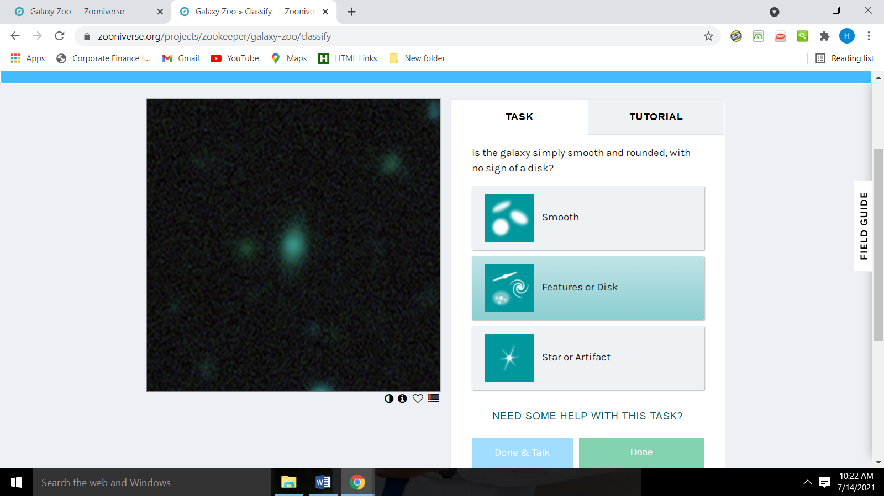 | This one was smooth
2 | 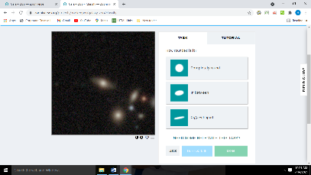 | This one had some major disturbance
3 | 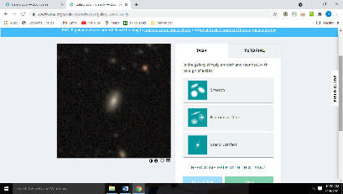 | This had some features in addition.
4 | 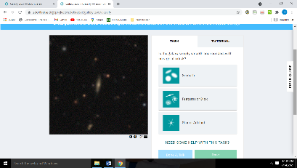 | This was smooth
5 | 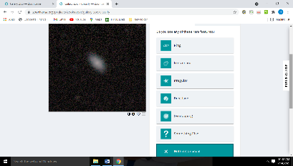 | This had no disturbance.

Write a paragraph describing the differences that you noted between your five galaxies. (4-5 sentences)
Galaxies are classified by shape. There are three general types: elliptical, spiral, and irregular. Perhaps the most familiar kind of galaxy are spiral galaxies. They have a distinctive shape with spiral arms in a relatively flat disk and a central "bulge", Each type has different characteristics and a different history of evolution. Some, like the Milky Way, have arms spiraling outward around their center

- When you classify galaxies in Galaxy Zoo Navigator, what types of questions are asked?
Is it smooth
Does it have any disturbance.
The shape of it.
The appearance
- Which features appear important to pay attention to?
The shape
The disturbance
The objects around it.

6. How do your answers to the first classification question compare to the
answers given by other Zoo members?
To do this:
- When you are in “Classify” under the object select “Done and Talk”

There may be comments or discussion which you can join, or you can select “Start Discussion” or “Add Comment About This Object.” If your object does NOT have any comments, continue until you find one that does. I also encourage you to start the discussion yourselves.
- OR Find the section on the site at the top that says TALK and join the Galaxy Zoo Discussion. This is a general forum, and not related to a single object.
Your task:
- Respond to another member and insert a screenshot.
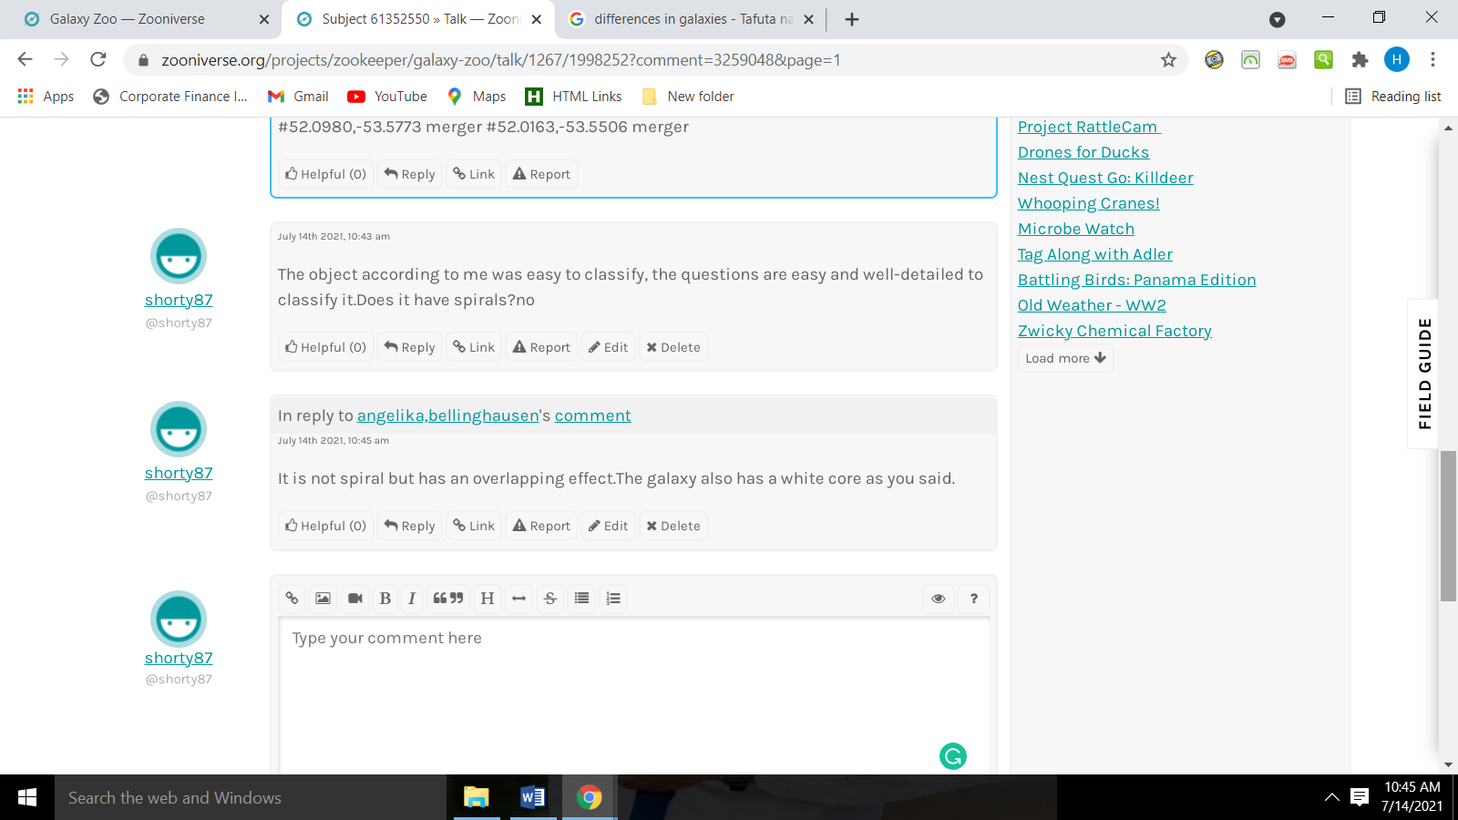

- Why do you think that not all members agree perfectly?
Because not all people see the same things.

NOTE: If working in groups-you must post EACH of your responses. Indicate on your page who is who.

Screenshot of member response

7. How does this project benefit society?
Think about what practical purpose might it have? Say more than just that it provides knowledge. If the website does not give any hint, think about it and think of a way that it could possibly be used to benefit society. (2-3 sentences)
Galaxies show us how the matter in the universe is organized on large scales. In order to understand the nature and history of the universe, scientists study how the matter is currently organized and how that organization has changed through out cosmic time.

8. Create a diagram of any shape or variety (chart, web, tree) to organize your galaxies. Explain your reasoning for organizing the objects in the way you chose.

Galaxy Organization Diagram
